
FACULTY OF ENGINEERING AND TECHNOLOGY
Electrical and Computer Engineering Department
ENCS4370 - Computer Architecture
Design and Implementation of a 32-bit Pipelined RISC Processor

Prepared by:
Name: Amir Abdel-Jabbar ID: 1231192
Name: Amjad Qaher ID: 1230800
Name: Hanan ID: 1230827

Supervised by:
Dr.Aziz Qaroush

Date: 21 June 2026

Abstract

Table of Contents

Table of Figures

Design and Implementation

Description of the processor Datapath

Instruction Fetch (IF) Stage
The IF stage is responsible for fetching the next instruction from memory. The Program Counter (PC) holds the address of the current instruction and feeds it into the Instruction Memory, which outputs the corresponding 32-bit instruction combinationally. A 32-bit Adder connected to the PC computes PC+1, producing the next sequential instruction address stored in the NPC register. The PC is updated every clock cycle through a 4-to-1 multiplexer controlled by PCSrc, which selects between PC+1 for sequential execution, the Branch Target Address (BTA) for taken branch instructions, the Jump Target Address for J and JAL instructions, and the register value Rs for the JR instruction. When a jump is detected in the ID stage the instruction currently in the IF stage is killed by flushing the IF/ID pipeline register, inserting a NOP bubble. At the end of the IF stage the fetched instruction and PC+1 are latched into the IF/ID pipeline register.

Instruction Decode (ID) Stage
The ID stage decodes the fetched instruction and reads the required register values. The IF/ID register releases the 32-bit instruction, which is split into its fields: the 6-bit opcode is sent to the Main and ALU Control Unit, the 4-bit Rs and Rt fields address the Register File read ports RA and RB producing BusA and BusB respectively, the 4-bit Rd field passes through a multiplexer controlled by RegDst to select the destination register, and the 18-bit immediate field enters the Extender Unit which produces a 32-bit sign or zero extended value controlled by ExtOp. For J-type instructions the 26-bit offset field passes through a separate Extender to compute the Jump Target Address, which is fed back to the PC multiplexer.
The ID stage also contains the 32-bit Comparator, which receives BusA and BusB and produces the Equal output used to resolve branch conditions early. The result is sent directly to the PC Control Unit alongside the BEQ, BNE, J, and JR signals to determine PCSrc. When a branch is taken two instructions are killed by flushing both the IF/ID and ID/EX pipeline registers. The Main and ALU Control Unit generates all control signals in this stage: RegDst, LinkSel, ExtOp, RegW, ALUSrc, ALUOp, MemRd, MemWr, Wbdata, and PCSrc. These signals, along with the Datapath values BusA, BusB, the extended immediate, and the register addresses Rs, Rt, and Rd2, are latched into the ID/EX pipeline register at the end of this stage.

Execute (EX) Stage
The EX stage performs the arithmetic or logical operation required by the instruction. The ID/EX register releases BusA, BusB, the extended immediate, and all control signals. A 2-to-1 multiplexer controlled by ALUSrc selects between BusB and the extended immediate as the second ALU operand. The ALU receives BusA as its first operand and the selected value as its second operand, and performs the operation specified by ALUOp, producing ALU_Result. The destination register address Rd2 passes through this stage as Rd3 to continue its journey toward the Write Back stage. The control signals consumed in this stage, ALUSrc, ALUOp, RegDst, and ExtOp, are not carried forward. The remaining control signals RegW, MemRd, MemWr, Wbdata, Branch, and Jump, along with the Datapath values ALU_Result, BusB (as the store data D), Rd3, and PC+1, are latched into the EX/MEM pipeline register at the end of this stage.
The Forwarding Unit monitors the register addresses Rd2, Rd3, and Rd4 alongside RegW signals from the EX/MEM and MEM/WB registers. When it detects that a result computed by a previous instruction is needed by the current instruction before it has been written back to the Register File, it asserts ForwardA or ForwardB to bypass the stale register file value and feed the correct result directly to the ALU input.

Memory Access (MEM) Stage
The MEM stage handles load and store operations. The EX/MEM register releases ALU_Result as the Data Memory address, BusB as the store data Data_in, and the control signals MemRd and MemWr. For store instructions (SW, SWAP) MemWr is asserted, and the Data Memory writes Data_in to the address on the negative clock edge. For load instructions (LW, SWAP) MemRd is asserted, and the Data Memory outputs Data_out on the positive clock edge. The negative edge write and positive edge read separation prevents read/write conflicts in the same cycle, which is essential for the SWAP instruction that asserts both simultaneously. The Equal output from the ID stage comparator and the Branch signal also pass through this stage to inform the PC Control Unit of any branch decisions that need to be resolved. The destination register address Rd3 continues as Rd4. At the end of this stage ALU_Result, Data_out, Rd4, RegW, and Wbdata are latched into the MEM/WB pipeline register.

Write Back (WB) Stage
The WB stage writes the result of the instruction back to the Register File. The MEM/WB register releases ALU_Result, Data_out, Rd4, RegW, and Wbdata. The Wbdata signal controls a multiplexer that selects the correct write-back value: 00 selects ALU_Result for arithmetic and logical instructions, 01 selects Data_out for load instructions, 10 selects PC+1 for the JAL instruction to link the return address into R14, and 11 selects zero for the CLR instruction. When RegW is asserted the selected value is written into the register addressed by Rd4 in the Register File. Register R0 is hardwired to zero, and any write targeting R0 is ignored regardless of the RegW signal.

Hazard Handling
The pipeline includes two hazard handling mechanisms. The Forward and Stall Unit detects load-use hazards, which occur when a load instruction (LW or SWAP) is immediately followed by an instruction that uses the loaded value. In this case, the unit asserts Stall, which freezes the PC and the IF/ID register by disserting PCWrite and IFIDWrite, while simultaneously inserting a NOP bubble into the ID/EX register by clearing all its control signals. This introduces one stall cycle, giving the load instruction time to complete the MEM stage before the dependent instruction reaches the EX stage. Data hazards that do not involve loads are resolved without stalling through the forwarding paths described in the EX stage. Control hazards caused by branch instructions are resolved in the ID stage using the comparator, and the pipeline is flushed accordingly when a branch is taken or a jump is detected.

Description of all processor components

Instruction Memory (IM)
The Instruction Memory is a read-only memory unit responsible for storing the processor's program instructions. It is implemented as a word-addressable memory with a 32-bit address space, giving a total physical capacity of 4 GB (2³⁰ × 32-bit words). For simulation purposes, the memory size is reduced to 1024 words due to simulator constraints, while the architectural specification of 4 GB is maintained.

The module operates with a single read port and performs combinational (asynchronous) reads, meaning the output instruction is available immediately when a valid address is applied, without waiting for a clock edge. This is consistent with the single-cycle processor design where the instruction must be available within the same clock cycle it is fetched.

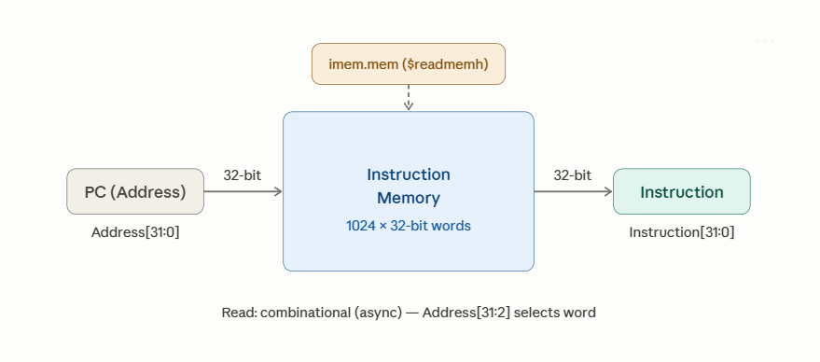
Figure 1: IM Block Diagram

The memory is initialized at the start of simulation, which loads hexadecimal machine code instructions from an external file imem.mem. The word address is derived from the input byte address by ignoring the two least significant bits of Address [31:2], enforcing word-alignment.

Data Memory (DM)

The Data Memory is a read-write memory unit responsible for storing and retrieving data during processor execution. It is implemented as a word-addressable RAM with a 32-bit address space, giving a total physical capacity of 4 GB (2³⁰ × 32-bit words). For simulation purposes, the memory size is reduced to 1024 words due to simulator constraints.
The module supports three memory-related instructions: LW, SW, and SWAP (exchange register with memory). It operates with one read port and one write port, controlled by MemRead and MemWrite signals, respectively.

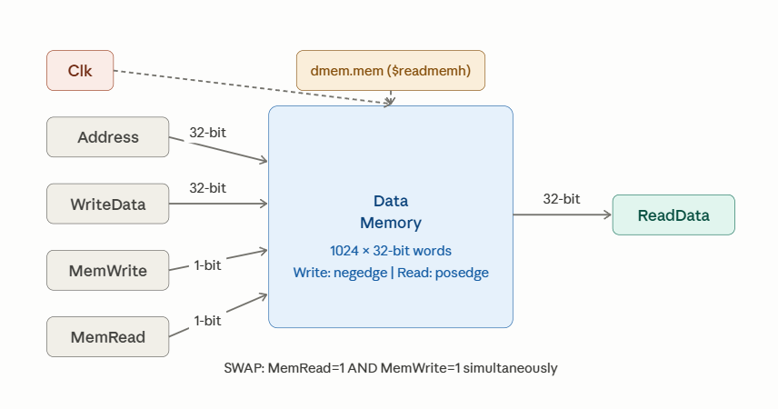
Figure 2: DM Block Diagram
In the single-cycle version, reads are combinational (asynchronous) and writes occur on the positive clock edge. In the pipelined version, reads occur on the positive clock edge, and writes occur on the negative clock edge, preventing read/write conflicts between the MEM and WB pipeline stages.
The word address is derived from the 32-bit byte address by ignoring the two least significant bits (Address [31:2]), enforcing word-alignment. The memory is initialized at simulation to start from an external file (dmem.mem).

Register File
The Register File is a storage unit containing sixteen 32-bit general-purpose registers, named R0 through R15. It is implemented using a 4-to-16 decoder for the write port and two 16-to-1 multiplexers for the two read ports, as required by the project specification.
The register file supports two simultaneous read operations, and one write operation per clock cycle. Reads are combinational (asynchronous), meaning the output data is available immediately when a valid register address is applied. Writes are synchronous, occurring on the positive clock edge when the RegWrite control signal is asserted.
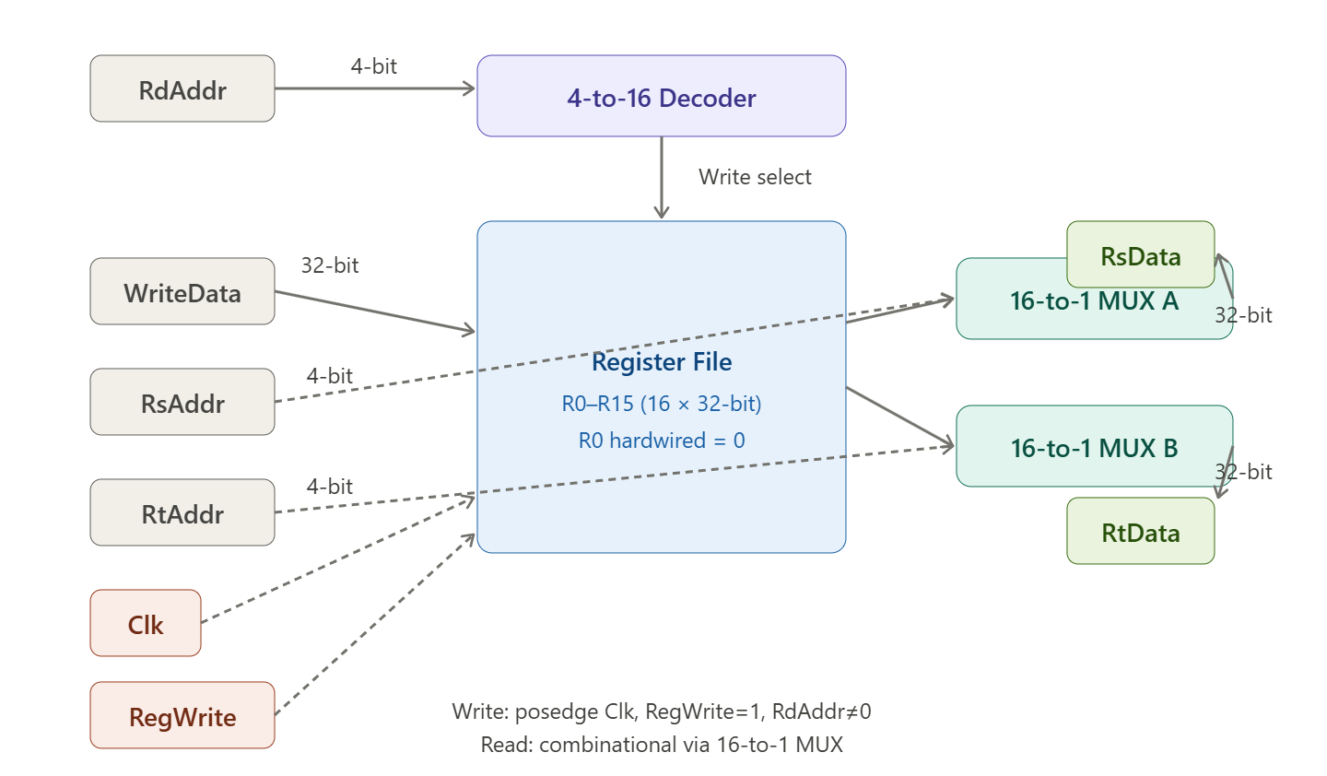
Figure 3: Register File Block Diagram
Register R0 is hardwired to zero — it always outputs the value 0x00000000 regardless of any write operation. Any attempt to write to R0 is silently ignored. This is enforced in hardware by checking the destination address before writing, and by forcing REG [0] to zero on every clock cycle.
The write port uses a 4-to-16 decoder that takes the 4-bit destination register address (RdAddr) and asserts exactly one of 16 output lines, selecting the target register. The two read ports each use an independent 16-to-1 multiplexer that selects one of the 16 register outputs based on the source register address (RsAddr or RtAddr).

2x1 32-bit Multiplexer

The 2-to-1 Multiplexer is a combinational selection unit that chooses between two 32-bit input signals, In0 and In1, based on a 1-bit select signal Sel. When Sel is 0 the output carries In0, and when Sel is 1 the output carries In1. The module is fully combinational with no clock dependency, meaning the output updates immediately whenever the inputs or select signal changes.

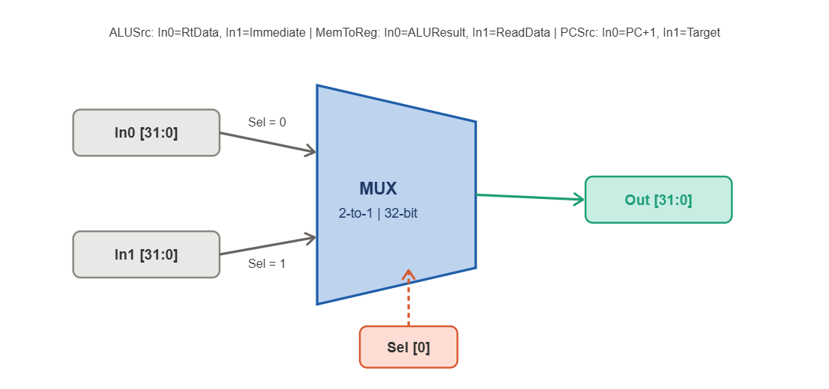Figure 4: 2x1 Mux Block Diagram

Multiple instances of this multiplexer appear across the Datapath serving different purposes: one instance selects between a register value and an immediate value as the second ALU operand controlled by ALUSrc, another selects between the ALU result and memory read data for the write-backstage controlled by MemToReg, and a third selects the next PC value between PC+1 and a branch or jump target controlled by PCSrc.

32bit Adder

The 32-bit Adder is a combinational arithmetic unit that computes the sum of two 32-bit input operands A and B, producing a 32-bit output Sum. The module is fully combinational with no clock dependency, meaning the result is available immediately when valid inputs are applied. Overflow is not flagged, , only the lower 32 bits of the result are produced.

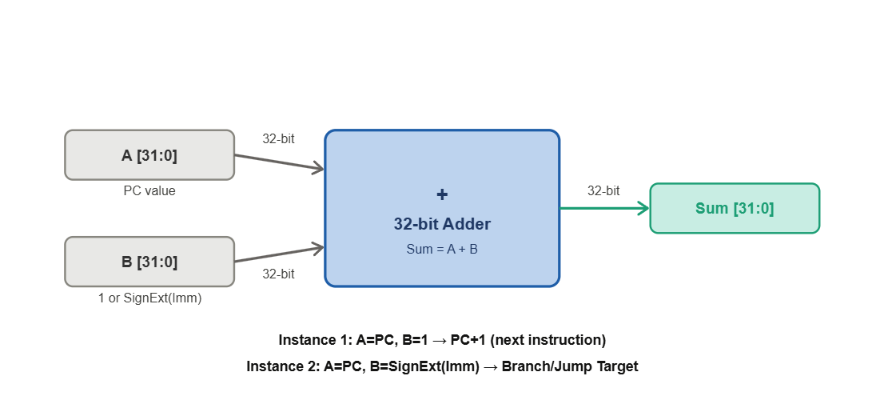Figure 5: 32-bit Adder Block Diagram

Two instances of this adder appear in the Datapath: the first computes PC+1 by adding the current program counter value to the constant 1, producing the next sequential instruction address; the second computes the branch or jump target address by adding the current PC value to the sign-extended immediate offset, producing the destination address for branch and jump instructions.

Comparator Unit

The 32-bit Comparator is a combinational unit responsible for evaluating the branch condition in the pipeline Instruction Decode (ID) stage. It takes two 32-bit operands A and B, which correspond to the values of the two source registers being compared, and produces a single-bit output Equal. The output is asserted high (Equal = 1) when the two inputs are identical, and disserted (Equal = 0) when they differ.

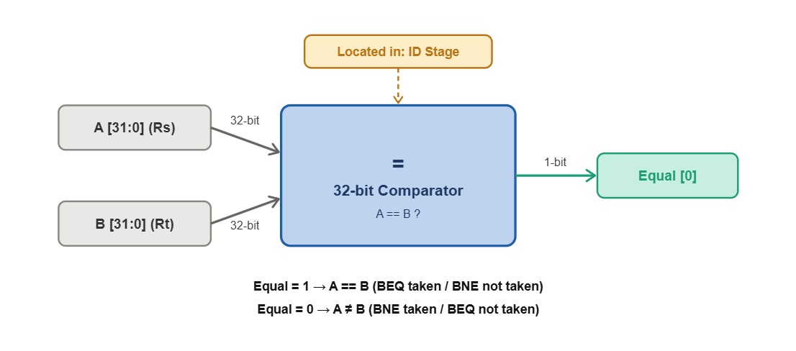Figure 6: 32-bit Comparator Block Diagram

By placing the comparator in the ID stage rather than the EX-stage, the branch decision is resolved at one stage earlier, reducing the branch penalty from two wasted cycles to one. The Equal output is used directly by the PC Control unit to determine the next PC value for BEQ and BNE instructions — a taken BEQ requires Equal = 1 while a taken BNE requires Equal = 0.

IF/ID Pipeline Register

The IF/ID Pipeline Register sits between the Instruction Fetch (IF) stage and the Instruction Decode (ID) stage. Its purpose is to latch and hold the values produced by the IF stage at the end of each clock cycle, making them available to the ID stage in the following cycle. It carries two Datapath signals: PC+1, which is the incremented program counter value needed for branch target computation and JAL linking, and Instruction, which is the 32-bit instruction fetched from the Instruction Memory.

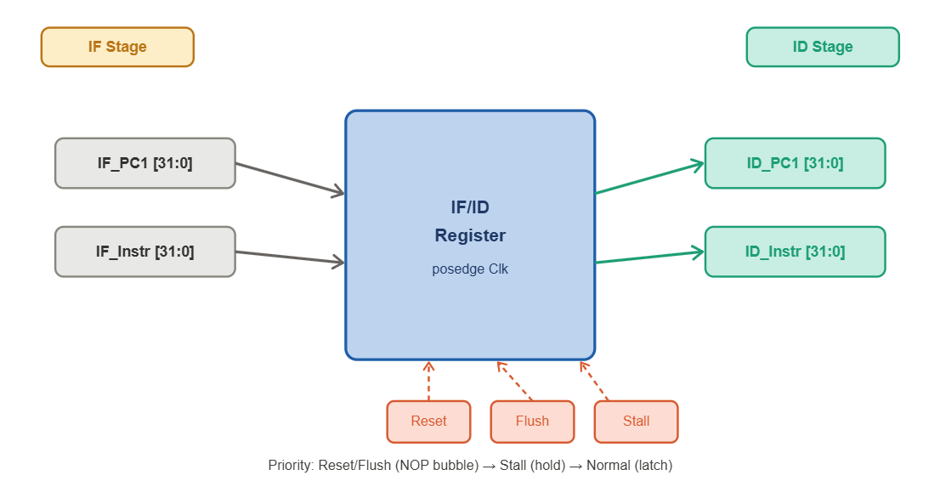Figure 7: IF/ID Pipeline Register Block Diagram

The register latches its inputs on the positive clock edge under normal operation. It supports three control conditions: when Reset or Flush is asserted the register is cleared to zero, inserting a NOP bubble into the pipeline — this occurs when a branch is taken or a jump is detected, killing the incorrectly fetched instruction. When Stall is asserted, the register holds its current value and ignores new inputs, freezing the pipeline during a load-use hazard. The Stall signal also disables the PC from updating, ensuring the same instruction is re-fetched on the next cycle.

ID/EX Pipeline Register

The ID/EX Pipeline Register sits between the Instruction Decode (ID) stage and the Execute (EX) stage. It is the largest pipeline register in the processor, carrying both Datapath signals and all control signals generated by the Control Unit in the ID stage forward to the EX-stage and beyond.
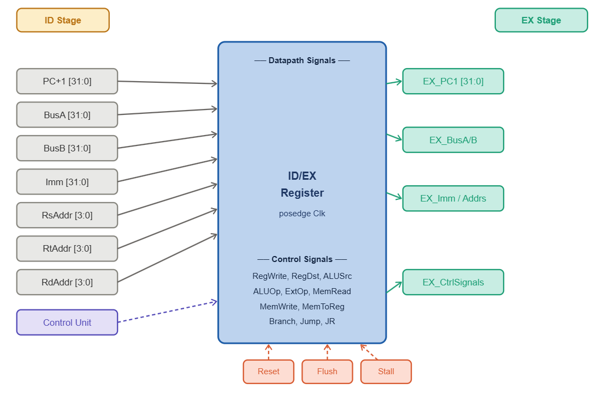Figure 8: ID/EX Pipeline Register Block Diagram
The Datapath signals it carries are PC+1 for JAL linking, BusA and BusB which are the two register file output values, the sign or zero extended immediate value Imm, the source register addresses RsAddr and RtAddr which are passed to the Forwarding and Stall unit for hazard detection, and the destination register address RdAddr (referred to as Rd2) which travels through subsequent pipeline registers until it reaches the Write Back stage. The control signals it carries are RegWrite, RegDst, ALUSrc, ALUOp, ExtOp, MemRead, MemWrite, MemToReg, Branch, Jump, and JR, covering every decision needed in the EX, MEM, and WB stages. All signals are latched on the positive clock edge. When Reset or Flush is asserted all outputs are cleared to zero, inserting a NOP bubble into the pipeline. When Stall is asserted all outputs hold their current values, freezing the pipeline stage during a load-use hazard.

EX/MEM Pipeline Register

The EX/MEM Pipeline Register sits between the Execute (EX) stage and the Memory Access (MEM) stage. It latches the results produced by the ALU in the EX-stage and passes them along with the remaining control signals to the MEM stage. The Datapath signals it carries are PC+1 which continues to travel through the pipeline for JAL linking, ALUResult which holds the computed result from the ALU used either as a memory address for load and store instructions or as the final write-back value for arithmetic and logical instructions, RtData which holds the value of the Rt register needed by the SW and SWAP instructions to write data into memory, RdAddr (referred to as Rd3) which is the destination register address continuing its journey toward the Write Back stage, and Equal which is the comparator output carrying the branch condition result from the ID stage to the PC Control unit.
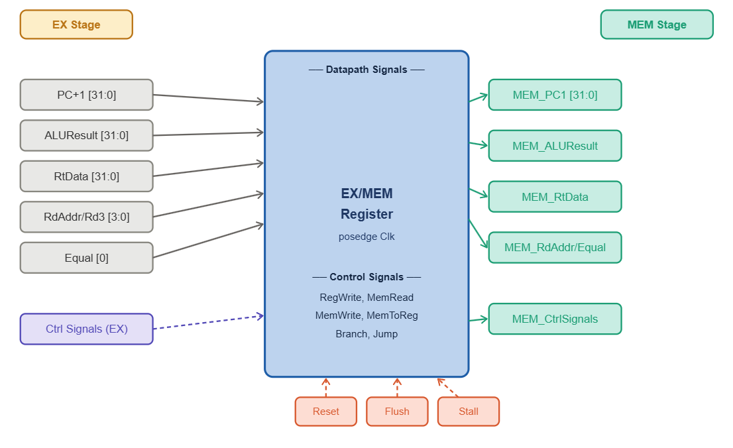Figure 9: EX/MEM Pipeline Register Block Diagram
The control signals it carries are the subset still needed from this stage onward: RegWrite, MemRead, MemWrite, MemToReg, Branch, and Jump. Control signals consumed in the EX-stage such as ALUSrc, ALUOp, RegDst, and ExtOp are not carried forward as they are no longer needed. All signals are latched on the positive clock edge. When Reset or Flush is asserted, all outputs are cleared to zero, and when Stall is asserted, all outputs hold their current values.

MEM/WB Pipeline Register

The MEM/WB Pipeline Register is the final pipeline register in the processor, sitting between the Memory Access (MEM) stage and the Write Back (WB) stage. It carries the smallest set of signals of all four pipeline registers since most control decisions have already been consumed by earlier stages. The Datapath signals it carries are ALUResult which holds the arithmetic or logical result from the EX stage passed through the MEM stage, ReadData which holds the data read from the Data Memory for load instructions, and RdAddr (referred to as Rd4) which is the destination register address that has traveled through all previous pipeline registers and finally reaches the Register File write port in the WB stage.

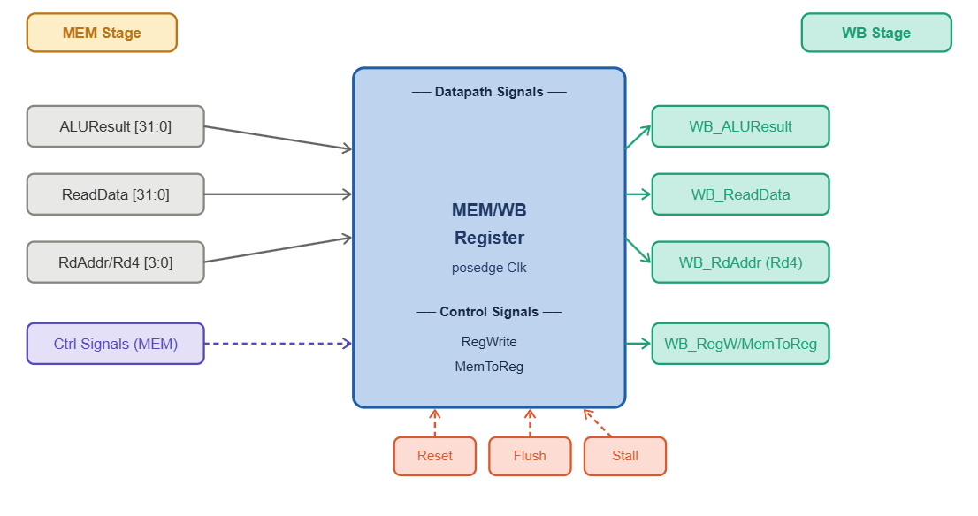Figure 10: MEM/WB Pipeline Register Block Diagram

The only control signals it carries are RegWrite which enables writing to the register file, and MemToReg which selects between ALUResult and ReadData as the value to write back. All signals are latched on the positive clock edge. When Reset or Flush is asserted, all outputs are cleared to zero, and when Stall is asserted, all outputs hold their current values.

ALU

The 32-bit ALU is a combinational unit that performs all arithmetic, logical, and shift operations required by the Datapath. It takes two 32-bit operands A and B, along with a 3-bit ALUCtrl code generated by the ALU Control Unit and produces a 32-bit Result along with a single-bit Zero flag. Zero is asserted when Result equals zero, which is the signal the PC Control Unit uses to resolve BEQ and BNE.

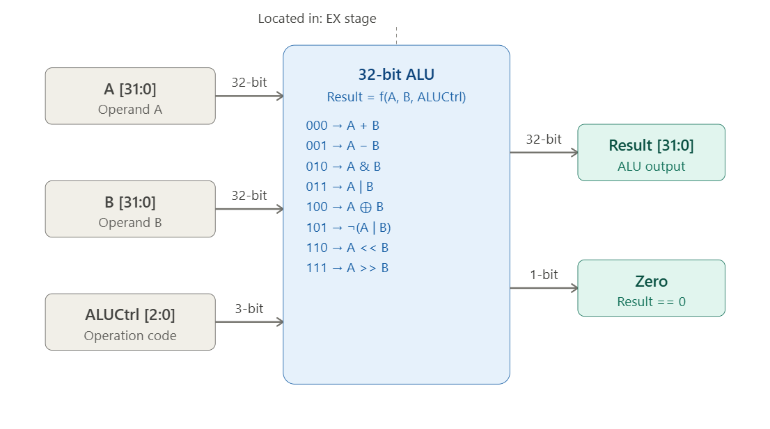Figure 11: 32-bit ALU Block Diagram

The 3-bit ALUCtrl code is generated by the ALU Control Unit, which itself decodes the ALUOp field together with the function of bits of R-type instructions. This separation means the main control logic never needs to know which specific ALU operation is selected — it only asserts a 2 or 3-bit ALUOp, and the ALU Control Unit translates that into the precise ALUCtrl code shown above. The Zero output is the only ALU signal consumed outside the EX stage: it feeds the original single-cycle PCSrc logic, but in the pipelined version branch resolution has been moved earlier to the dedicated Comparator in the ID stage, so Zero from the ALU is only relevant for ALU-result-based decisions, not branch outcomes.

Program counter (PC) register

The PC register is a 32-bit synchronous, edge-triggered register that holds the address of the instruction currently being fetched. On every rising edge of the clock, it loads the value present on its input, unless reset is asserted, in which case it is forced to zero regardless of the clock's edge timing within that cycle. It has no enable input of its own — when the pipeline needs to hold the PC steady during a stall, this is done upstream, by holding the value fed into in constant rather than by gating the register's own clock.

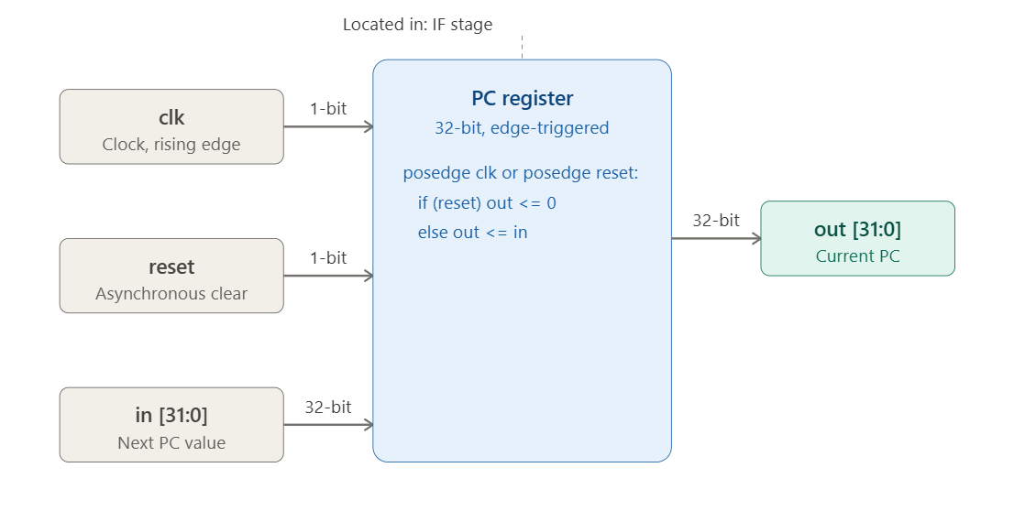Figure 12: PC Register Block Diagram

In the pipelined processor, out is the value latched at the start of the IF stage, and in is computed combinationally by the PC Control unit one cycle earlier from PCSrc, the jump target, the branch target, or the register value for JR. The asynchronous reset is included so the whole pipeline can be brought to a known state independent of the clock, which matters at power-up and for any global flush condition that needs to override normal sequencing.

Description of the control signals

The processor's control logic was developed in two stages. It started as a single-cycle design with control signals generated by the Main and ALU Control Unit, decoding the opcode in a single combinational pass within one clock cycle.
When the design was extended into a five-stage pipeline, these same control signals were retained unchanged in meaning — they are simply generated in the ID stage now and carried forward through the pipeline registers alongside the instruction. On top of this, three new control signals were introduced that exist only because instructions now overlap in time: Stall, Flush, and the Forwarding selects, produced by the newly added PC Control Unit and Forward and Stall Unit to resolve the hazards that overlapping execution creates.

The Main and ALU Control Unit decodes the 6-bit opcode field of each instruction and generates the following signals. RegDst selects the destination register, asserting 1 to select Rd for R-type instructions and 0 to select Rt for I-type instructions. LinkSel is asserted only for the JAL instruction to link the return address by writing PC+1 into register R14. ExtOp controls the Extender Unit, asserting 1 for sign extension used by arithmetic and memory instructions and 0 for zero extension used by logical immediate instructions. RegW enables writing the result back to the register file at the end of execution.

ALUSrc selects the second ALU operand, asserting 1 to use the extended immediate value and 0 to use the register value BusB. MemRd enables reading from the Data Memory for load instructions. MemWr enables writing to the Data Memory for store instructions.

Wbdata is a 2-bit signal that selects the write-back data source, where 00 selects the ALU result, 01 selects the memory read data, 10 selects PC+1 for JAL, and 11 selects zero for CLR. PCSrc is a 2-bit signal that selects the next program counter value, where 00 selects PC+1 for sequential execution, 01 selects the jump target address for J and JAL, 10 selects the branch target address for taken BEQ and BNE, and 11 selects the register value for JR.

These signals are unchanged from the original single-cycle design — the only difference in the pipeline is when PCSrc is resolved. In a single-cycle Datapath PCSrc could be computed and acted on within the same cycle. In the pipeline, branch and jump outcomes are determined earlier, in the ID stage rather than the EX stage, specifically so the PC Control Unit can correct a misprediction one cycle sooner.

The pipeline introduces three additional control signals that have no single-cycle equivalent, because they exist only to manage instructions that are now in flight simultaneously. Stall is generated by the Forward and Stall Unit when a load-use hazard is detected, freezing the PC and the IF/ID register while inserting a NOP bubble into the ID/EX register.

Flush is generated by the PC Control Unit when a branch is taken, or a jump is detected, clearing the pipeline registers to eliminate incorrectly fetched instructions. ForwardA and ForwardB are 2-bit signals generated by the Forwarding Unit that select the correct operand values for the ALU inputs, bypassing stale register file values with more recently computed results from the EX/MEM or MEM/WB pipeline registers.

Control truth tables

The following truth tables define the control signal values for each instruction. Table 4.1 shows the ALU operation coding, Table 4.2 shows the main control signals, and Table 4.3 shows the PCSrc values with the Z flag condition.

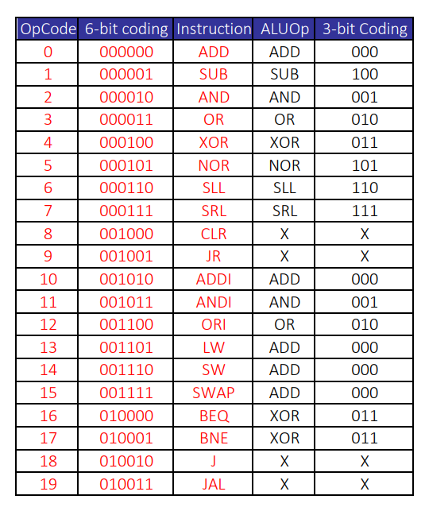

Table 1: ALUOp Coding

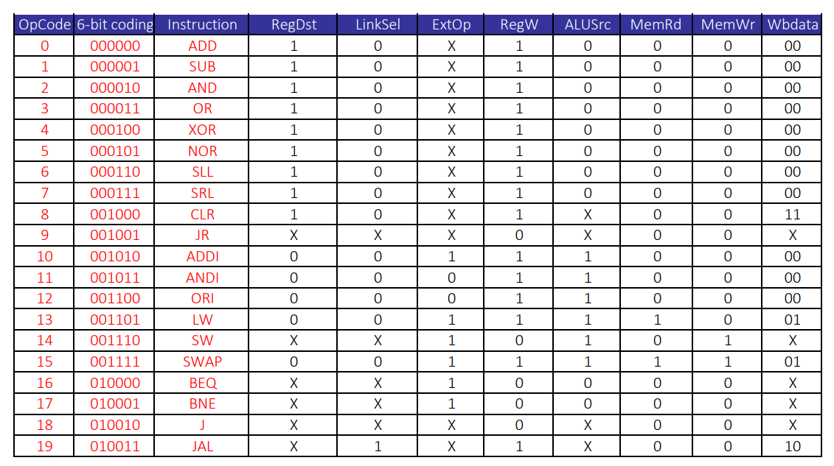Table 2: Main Control Signals
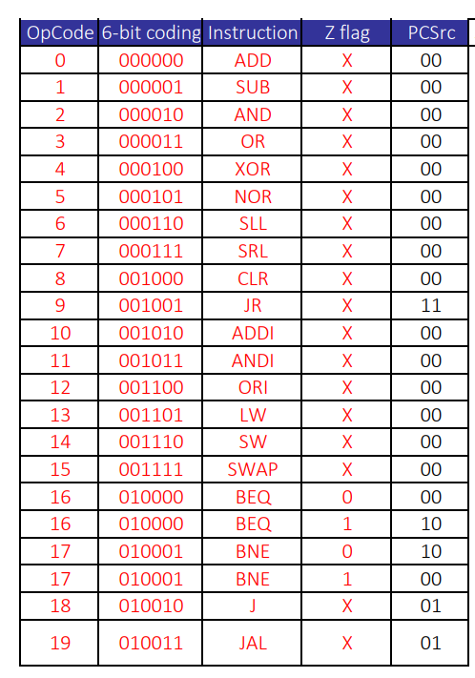
Table 3: PCSrc with Z flag

Boolean equations and Logic diagrams

The control signals are derived from the 5-bit opcode representation of A4A3A2A1A0. The following equations describe the logic for each signal. For the single-cycle control signals, the equations are derived from the truth table. For the pipeline-specific signals, the equations are derived from the hazard and forwarding conditions.
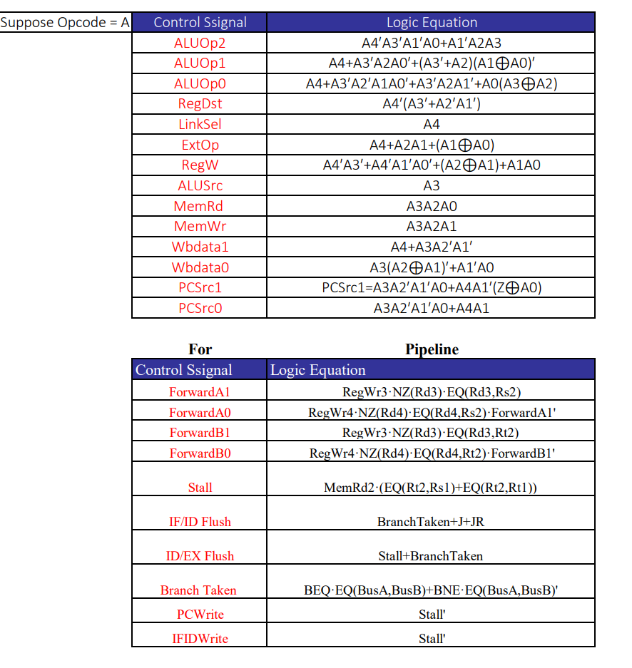
Table 4: Single cycle & Pipeline Logic Equations

Datapath and control-path diagrams

Single-Cycle Processor Datapath
The single-cycle processor Datapath is illustrated in the figure below. The Datapath follows a left-to-right flow beginning at the Program Counter (PC), which supplies the current instruction address to the Instruction Memory. A 32-bit Adder connected to the PC computes PC+1, which feeds back through the PC multiplexer to advance to the next sequential instruction. The fetched 32-bit instruction exits the Instruction Memory and is distributed across the Datapath: the 6-bit opcode drives the Main and ALU Control Unit, the 4-bit Rs and Rt fields address the Register File read ports RA and RB, the 4-bit Rd field passes through a multiplexer controlled by RegDst to select the write destination W, the 18-bit immediate field enters the Extender Unit producing a 32-bit extended value controlled by ExtOp, and the 26-bit offset of J-type instructions passes through a separate Extender to compute the jump target address.
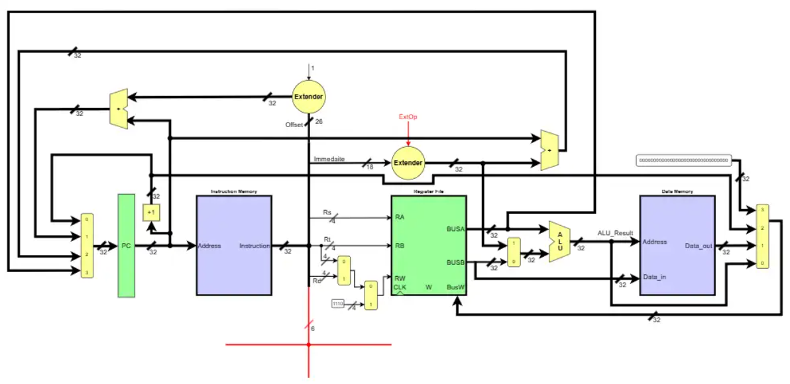Figure 13: Single-Cycle Processor Datapath
The Register File outputs BusA and BusB carry the two register values into the ALU. A 2-to-1 multiplexer controlled by ALUSrc selects between BusB and the extended immediate as the second ALU operand. The ALU computes ALU_Result, which serves as both the Data Memory address and a candidate write-back value. The Data Memory receives ALU_Result as its address and BusB as Data_in for store operations, controlled by MemRd and MemWr. A write-back multiplexer controlled by Wbdata selects between ALU_Result, Data_out, and PC+1 and routes the selected value back to Register File Write port BusW. The PC multiplexer, controlled by PCSrc, selects between PC+1, the branch target address, the jump target address, and the JR register value to update the PC each clock cycle.

Pipelined Processor Datapath
The pipelined processor Datapath is illustrated in the figure below. It is built directly on top of the single-cycle design by inserting four pipeline registers between the five execution stages: IF/ID between the Instruction Fetch and Instruction Decode stages, ID/EX between the Instruction Decode and Execute stages, EX/MEM between the Execute and Memory Access stages, and MEM/WB between the Memory Access and Write Back stages. Each pipeline register latches its input signals on the positive clock edge and transfers them to the next stage, allowing multiple instructions to be in different stages of execution simultaneously.
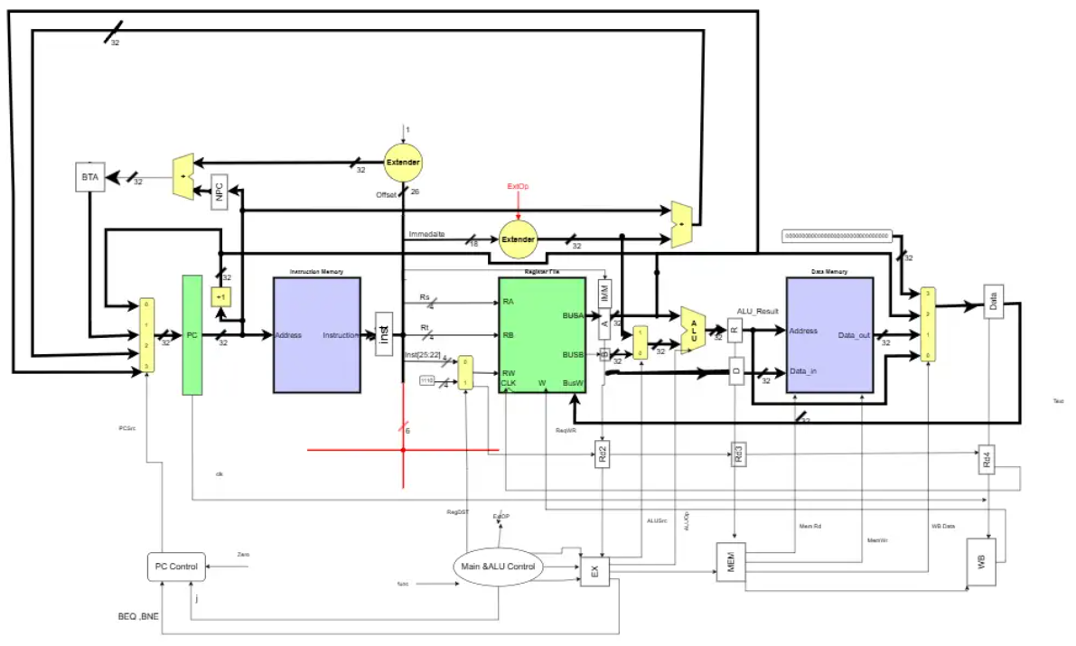
The control path is separated into three units visible at the bottom of the figure. The Main and ALU Control Unit generate all Datapath control signals in the ID stage. These signals propagate forward through the pipeline registers, the EX-register carries signals needed by the Execute stage such as ALUSrc, ALUOp, RegDst, and ExtOp, the MEM register carries signals needed by the Memory Access stage such as MemRd and MemWr, and the WB register carries signals needed by the Write Back stage such as RegW and WBdata. The PC Control Unit receives the Zero flag, the J signal, and the BEQ/BNE signals to determine the correct next PC value and generate PCSrc. The destination registers addresses Rd2, Rd3, and Rd4 travel through the pipeline registers alongside the data signals, ensuring the correct register is written at the Write Back stage regardless of how many cycles have passed since the instruction was decoded.

The pipelined Datapath also introduces the NPC register which holds PC+1 in the IF stage, and the IMM and D registers in the EX-stage which hold the extended immediate and BusB values respectively. The pipeline supports flush and stall operations for hazard handling, where flushing clears pipeline registers to insert NOP bubbles on branch or jump detection, and stalling freezes the PC and IF/ID register on load-use hazards.

Design decisions and justifications

Memory Size Reduction for Simulation. The architectural specification requires a 4 GB word-addressable memory equivalent to 2³⁰ × 32-bit words. Allocating a memory array of this size in Active-HDL causes a fatal elaboration error during simulation due to host memory constraints. The memory size was therefore reduced to 1024 words for simulation purposes while maintaining the full 32-bit address interface. The word address is still derived from bits [31:2] of the byte address and the lower 10 bits index into the simulation array. This decision preserves architectural correctness while enabling functional simulation.
Register File Implementation Using Decoder and Multiplexers. The register file was implemented using a 4-to-16 decoder for the write port and two independent 16-to-1 multiplexers for the two read ports, as explicitly required by the project specification. This structural implementation reflects real hardware design, where the decoder generates a one-hot write enable signal selecting exactly one register per cycle, and the multiplexers select the output of the addressed register for reading without requiring a clock edge.
R0 Hardwired to Zero. Register R0 is permanently forced to zero through two enforcement mechanisms: the write logic checks the destination address and ignores any write targeting R0, and an always block continuously reassigns REG [0] to zero on every positive clock edge. This ensures R0 behaves as a constant zero source regardless of any instruction that attempts to write to it, consistent with the ISA specification.
Synchronous Write and Asynchronous Read. Reads from the Register File and Instruction Memory are combinational, ensuring values are available within the same clock cycle they are needed. Writes to the Register File and Data Memory are synchronous, occurring on the positive clock edge to maintain data integrity and prevent race conditions within a single cycle.

Modified Data Memory Timing for Pipeline. In the pipelined processor, the Data Memory was modified to perform reads on the positive clock edge and writes on the negative clock edge. This edge separation ensures that simultaneous read and write operations targeting the same memory location do not conflict. This is particularly critical for the SWAP instruction, which asserts both MemRead and MemWrite in the same cycle to atomically exchange a register value with a memory location.
Pipelined Design Built on Single-Cycle Foundation. Rather than designing the pipelined processor from scratch, it was implemented by extending the verified single-cycle design. The same modules — Instruction Memory, Data Memory, Register File, ALU, Extender Unit, and Control Unit — were reused without modification. Pipeline registers were inserted between stages, and the Data Memory timing was adjusted for pipeline operation. This approach reduced design complexity, reused verified components, and made debugging significantly easier since each module had already been validated in the single-cycle context.
Comparator Placed in the ID Stage. The branch comparator was deliberately placed in the Instruction Decode stage rather than the Execute stage. By resolving the branch condition one stage earlier, the branch penalty is reduced from two wasted cycles to one. When a branch is taken only the IF/ID register needs to be flushed, whereas resolving the branch in the EX stage would require flushing both IF/ID and ID/EX registers, wasting two cycles per taken branch.
Pipeline Registers Supporting Reset, Flush, and Stall. All four pipeline registers were designed with a clear priority ordering among three control conditions. Reset and Flush take highest priority and clear all outputs to zero, inserting a NOP bubble into the pipeline on branch taken or jump detection. Stall takes second priority and holds all current values, freezing the pipeline during a load-use hazard. Normal operation latches new input values on the positive clock edge. This priority ordering guarantees correct behavior during all hazard scenarios.
Forwarding to Minimize Pipeline Stalls. The processor implements a forwarding unit that detects data dependencies between instructions in different pipeline stages and bypasses the register file by feeding the most recently computed value directly to the ALU inputs through ForwardA and ForwardB multiplexers. EX-to-EX forwarding takes priority over MEM-to-EX forwarding when both conditions are simultaneously true, ensuring the most recent value is always selected. This significantly reduces the number of pipeline stalls and improves processor throughput compared to a stall-only hazard resolution strategy.

Simulation and Testing

Description of all test programs

Expected output for each test

Simulation results, Waveform screenshots

List of instructions verified successfully

Limitations & issues

Teamwork
Each member carries an equal one-third share, but the work splits along a clean, non-overlapping line, single-cycle and pipeline responsibilities for the same component generally stay with the same person, so each piece of hardware has one clear owner across both phases.
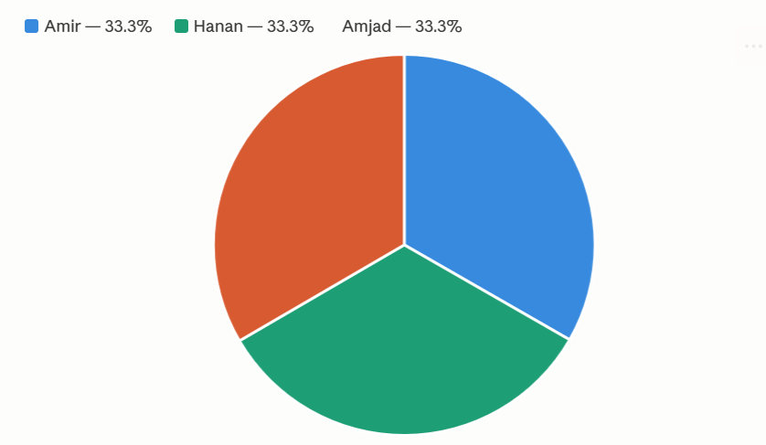
Amir (33.3%) — Memory units (IM, DM), register file, the 32-bit adder and 2-to-1 mux, the single-cycle assembly test program, then extending into the pipeline: synchronizing Data Memory to split-edge read/write, designing all four pipeline registers, building the Comparator unit, and producing the full control-signal spreadsheet.
Hanan (33.3%) — The ALU and Extender unit plus their single-cycle test program, then the heaviest verification load on the pipeline side: the complete pipelined processor testbench covering every stage, write-back, memory ops, and branch behavior, plus redrawing the architecture diagram from single-cycle to five-stage pipeline.
Amjad (33.3%) — The Control Unit and full system integration for the single-cycle design, then carrying that same role forward as the person who assembles and integrates the entire five-stage pipeline, wires in every component, and supports final validation against Hanan's testbench.
So, the 33.3% split isn't just an even division of task count; it's structured, so each person owns a layer (memory/registers, compute/verification, control/integration) end-to-end across both the single-cycle and pipelined versions of the processor.

References

- Lucid Software Inc. Lucidchart. Used for creating flowcharts, diagrams, and system visualizations. Available at: https://www.lucidchart.com
- JGraph Ltd. draw.io (diagrams.net). Used for designing processor datapath diagrams and architectural illustrations. Available at: https://www.diagrams.net
- David A. Patterson and John L. Hennessy, Computer Organization and Design: The Hardware/Software Interface, Morgan Kaufmann. (Used as a reference for computer architecture concepts, datapath design, and processor organization.)
- David A. Patterson and John L. Hennessy, Computer Architecture: A Quantitative Approach, Morgan Kaufmann. (Referenced for advanced computer architecture principles and performance analysis.)
- Morris Mano and Michael D. Ciletti, Digital Design, Pearson. (Referenced for digital logic design, combinational and sequential circuits, and hardware fundamentals.)
- Course lecture slides, laboratory materials, and instructor-provided resources used throughout the implementation and analysis of the project.

